Ideation Phase
Brainstorm & Idea Prioritization Template

Date | 15/07/2026
Team ID
Project Name | A Comprehensive Measure of Well-Being: HDI Prediction
Maximum Marks | 4 Marks

Team Gathering, Collaboration and Select the Problem Statement
Governments, researchers, and policymakers face challenges in accurately evaluating and predicting the Human Development Index (HDI) because socio-economic data is complex, comes from multiple sources, and requires extensive manual analysis. An intelligent prediction system is needed to provide accurate, data-driven insights for effective decision-making.
Step-1: Team Gathering, Collaboration and Select the Problem Statement
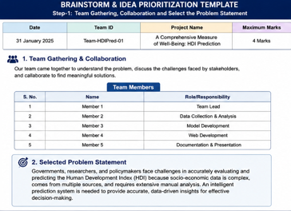
Step-2: Brainstorm, Idea Listing and Grouping


Step-3: Idea Prioritization
